**UI Design and Prototyping Report Template**

**Hitching booking system for students**

Let’s define a *driver* as a student who own a car and a *passenger* as also a student who needs a ride to/from the university. This platform that allows university students to communicate both drivers and passengers in order to optimize the transport to/from the campus.

The website may allow users to register, post offers and request a ride on certain date and time. In addition, it would exist some extra-parameters for a better match such as; smoking, music, conversation topics, etc.

Finally, both drivers and passengers could set a list of rules that allows them to emit a review after the ride.

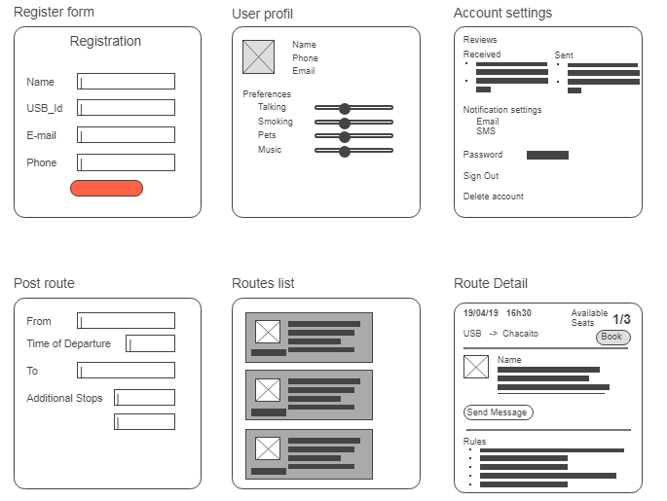

Fig. 1 – Application views

Users start with the register/login page, after that they setup their profile and account settings as in the tree views on top (Fig 1).

After that, every user will be able to post a route or book one.

Every card, will have relevant information such as: “From”, “To”, “Time of departure”, “Available Seats”, “Description”, “Driver photo”, etc.

Drivers should have access to their posted routes, their booked users, book requests, etc.

Passengers should have access to their requested routes and the list of available routes.

**References:**

https://www.blablacar.es/  
https://amovens.com/  
https://www.mobicoop.fr/  
https://www.covoiturage.ca/